AI-Driven Crop Disease Prediction and Management System

S. Aarif Ahamed
Assistant Professor Senior Scale
Department of Computer Science Engineering
Presidency University
Bangalore, India
aarifahamed10@gmail.com

Gundluri Gnana Sree
B Tech Student
Computer Science Engineering
Presidency University
Bangalore, India
gnanasree.gundluri@gmail.com Mounika A
B Tech Student
Computer Science Engineering
Presidency University
Bangalore, India
mounikamouna2004@gmail.com
Soujanya Jambagi
B Tech Student
Computer Science Engineering
Presidency University
Bangalore, India
jambagisoujanya@gmail.com

ABSTRACT
Farming is a major sector in the Indian economy, some of the crops like Ragi(finger millet) are important to food security, and economic survival of the farmers. But the farmers are usually confronted with problems such as crop disease, pest attacks unreliable weather conditions that interfere with the production. This paper presents a proposal of an automated deep learning-based system that can early identify the Ragi leaf diseases by classifying their images by various Convolutional Neural Network(CNN)-based architectures such as Resnet50 and Convnext-Tiny were trained on processed using augmented leaf images datasets. The most effective model was launched in the form of a web application based on a Flask, which help the farmers to upload the leaf pictures and automatically get predictions of the disease. The system improves accuracy and also reduces the number of minutes spent while performing manual inspections, as well as fostering data-driven and sustainable farming.
Keywords—Ragi, Convolution Neural Network, Convnext-Tiny, ResNet50, Sustainable farming.

1.INTRODUCTION

1.1 Agriculture in India

The Indian economy heavily depends on agriculture as a pillar, with most of its population being supported by agriculture, and also as a contributor to the GDP.

Ragi is of great significance because it has health benefits and is able to grow in dry regions among other crops. Ragi is experiencing such problems as infestation of pests, unpredictable weather, and diseases that reduce the yield and income. In such cases, especially in ragi leaf diseases, there is a significant impact on the quality and quantity of the crop. Disease detection can be done naturally, which is prone to errors. The solutions to these problems are provided by the implementation of new technologies, such as deep learning and image processing, which allow identifying them automatically, predicting early and practicing sustainable agriculture.

1.2 Challenges

The intermittent rains, drought and water scarcity in certain regions make the plants less resistant and soil erosion and loss of nutrients impact on the health of plants. The symptoms of the diseases such as pest attacks complicate predicting issues and would demand the use of advanced AI models. The absence of quality image datasets, poor access to the internet in the rural regions and dynamic patterns of disease complicate the realization of real-time monitoring further, necessary of the constant update of models and the effective collection of data to control disease.

1.3 Objective

This Project is dedicated to the establishment and introduction of an interconnected system, which is supposed to identify the symptoms of ragi disease based on AI algorithms and visual analysis tools. The new method examines the diseases of the plants by immediately identifying the patterns of symptoms in the image data. This will assisting farmers to identify the disease at the earliest stage and proceed to take on time measures to ensure that they are adequately taken care. This is done by reducing loss of crops, ensuring productivity and aiding evidence-based choices on ragi farming. This system will also help to decrease the human error during inspections by advancing to greenery farming that consumes pesticides efficiently and also availing the convenient technologies to rural farmers to facilitate the farm operations.

2. LITERATURE SURVEY

Scientists have significantly improved the use of Artificial Intelligence to predict and manage crop diseases in more efficient manner over the last few years. The AI-based crop disease management system suggested by Shisir Shastry et al.(2025) and Karthikeyan et al.(2025) can detect plant diseases, as well as give farmers recommendations on how to treat them successfully, which makes the proposed systems even more useful and efficient in the sphere. Ashurov et al.(2025) introduced a deep depthwise CNN architecture, which incorporates squeeze-and –excitation modules and residual connections and achieves high accuracy but has a small footprint enough to be applicable in real-time application. Similarly, Nigar et al.(2024) highlighted explainable AI to allow farmers and agronomists to understand the reason why the model is making these predictions and make more assured decisions. It was also demonstrated by Sharma et al.(2020) that transfer learning and fine-tuning of deep learning models can significantly increase the detection of diseases especially with the use of small agricultural datasets. Subsequently, researchers, such as Grow Pro by Suthendran et al.(2025) and LeafGuard by Dudla Anil Kumar et al.(2025), oriented their work towards disease recognition and decision-making in real-time using deep learning to offer faster responses against crop infections. These studies, collectively, are a clear break of the classical image-based detection, to the multifaceted approaches based on AI, that make a tradeoff between precision and interpretability versus everyday decision-making. However, despite these developments, such problems as integrity of the model in diverse environmental circumstances and field experiments are open problems to be resolved.

3.PROPOSED METHODOLOGY

3.1 Introduction

Ragi farming has a new direction, which should address its challenges and introduce an intelligent tool that detects diseases in early stage.

Through advanced algorithms such as deep neutral networks and stable-of-the-art imaging techniques, this system can successfully detect different diseases in plant leaves using digital photographs posted on a user-friendly web application created with the help of the Flask framework of the Python. Adaptable architecture guarantees the capability of the system to expand and to react promptly to novel information regarding diseases through which farmers will obtain correct advice of safeguarding crops.

3.2 Modules

3.2.1 Plant Disease Detection

Convolutional Neural Networks(CNNs) are employed in this module to evaluate the photos of ragi plant leaves and identify diseases at an early stage. It is then the model that is trained to recognize common ragi diseases through a set of healthy and diseased ragi leaf images that are gathered in relation to this project. The system enables farmers to engage in preventive measures, minimize loss of their crop and eliminate senseless application of pesticides through early detection. The web interface is fully compatible with the module, and it provides immediate access to disease information and recommendations.

3.2.2 Disease Detection Module

The module is based on deep learning and the detection of diseases in ragi leaves. The trained model such as Convolutional Neural Network, Convnext-Tiny, ResNet50 is capable of detecting infection at early stages thus preventing the farmers against the infections. This is the core component of the system and it provides efficient and reasonable disease diagnosis to enhance crop health and productivity.

3.2.3 Dataset Preparation Module

This module is concerned with collecting data and processing these data to detect the disease. Photographs of ragi leaves with different diseases such as smut, Downy mildew, Mottle, Seedling, Wilt were collected and pre-processed by resizing, normalization and removal of noise. Methods of data augmentation such as rotation, flipping and alteration of brightness were employed to diversify the dataset and avoid overfitting. The trained models are based on the ready-made dataset, which guarantees the effective and stable classification of diseases.

3.3 System Integration

The suggested deep learning architecture of ragi leaf disease detection is embedded into a user-friendly web-based application based on Flask. The application is written in HTML, CSS, Javascript and the front end offers a simple and interactive experience to the farmers. With the aid of this web application, users may submit pictures of ragi leaves and these pictures are fed through a trained CNN model to provide real-time information about the presence of the disease. The frontend and backend communicate smoothly and this is made possible by effective API connections. The platform saves time and enables farmers to take fast and informed decisions with quick and precise results of disease detection without the need to perform manual inspections. The combination of the forces of AI-based prediction with practical applications in the agricultural sector will make it approachable and scalable.

4.RESULTS AND DISCUSSIONS

4.1Accuracy

The user-friendly web interface of the ragi leaf disease detection system demonstrated in Figure 2.The system is made simple, intuitive and user-friendly so that it can be accessed by those having limited technical skills. The back end, designed with Flask, manages model integration, data processing, trained with multiple models increasing the accuracy.

4.2 Scalability

The neural networks of deep learning can be re-trained using new data of other plants or locations. This enables it to perform in other agricultural conditions. The system also performs on web platform. Flask, hence making it simple to integrate it with the rest of the information such as weather or field data without it. The system is accurate and fast since this is a cool thing. It is also suitable to large farms in other places and climates.

4.3 Limitations

Although the system works well for detecting ragi leaf diseases, its performance heavily depends on the quality, variety and amount of data used for training. It can be less accurate in analyzing low-light images of plants and those of other cameras. Moreover, the existing arrangement is ragi specific and would have to be retrained or modified to detect disease in crops.

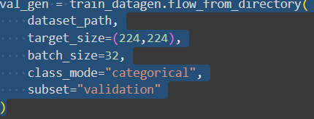

Fig 1. This image represents Image Preprocessing code

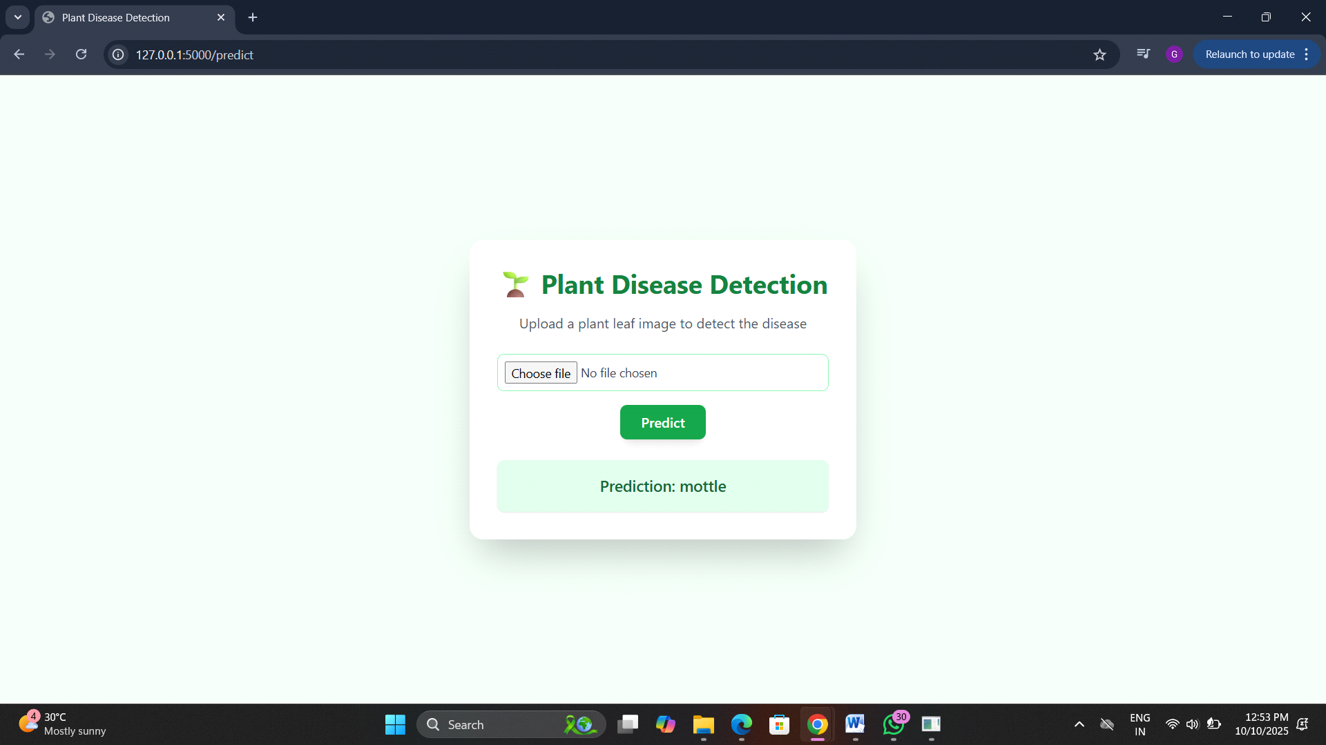

Fig 2. This image represents plant prediction using an image

4.4 Comparison Table

Model Name | Accuracy
Dense net | 100.0
Resnet | 96.0
CNN | 96
Convnext-Tiny | 50
Efficient Net | 50

Table 1. Comparison of models

4.5 Graphs

4.5.1Model Accuracy vs. Epoch

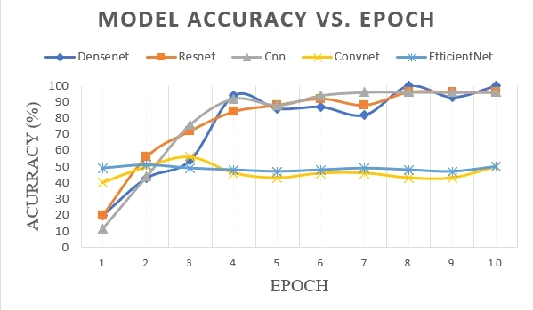
Fig 3. This image represents the model accuracy with respect to the number of epochs for various models like Dense net, Resnet, CNN, Convnext, and Efficient Net.

4.5.2 Loss Curves for Training Data and Validation Data

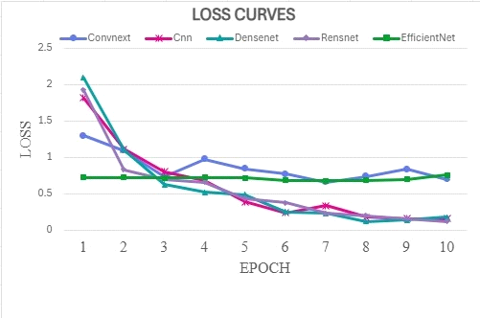

Fig 4.This image represents loss curves of training data of different models such as Convnext, Dense net, Resnet, CNN Efficient Net over 10 epochs.

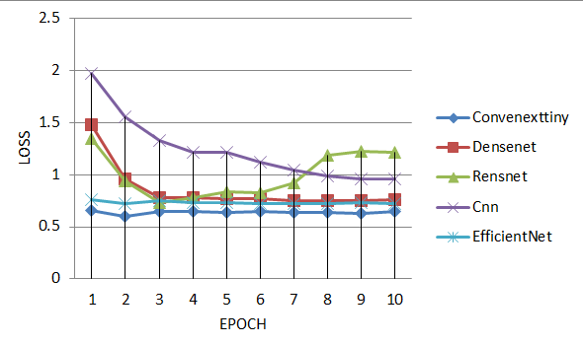

Fig 5. This image represents the loss curves of validation data of different models such as Convnext, Dense net, Resnet, CNN and Efficient net over 10 epochs.

5.CONCLUSIONS

This Project is AI-Driven Crop Disease Prediction and Management System demonstrates the deep learning models that are based on the many convolutional neural networks that provides the maximum accuracy. It is an web application that also allows farmers to post pictures easily and get immediate feedback successfully. Not only does this system save manual labor and human error but also provides a scalable model and would promote agriculture increasing the yield of crop and financial risk. It also expands the development of country and technology the agriculture business which is useful for agriculturalists and improves the security of the food in the world.

ACKNOWLEDGEMENT

We owe the success of the AI-Driven Crop Disease Prediction and Management System project to all the people who assisted us. I want to give a huge credit to our project guide and the Presidency University staff who helped us and guided us in the development with all the tips. Their consistent feedback and encouragement made us to contribute the real world project that solves the one of major agricultural problem. We are also appreciable for the farmers for sharing their challenges in agricultural field which made us to work for improving food security for the country. This helped us to tackle the crop diseases and agricultural problems.

REFERENCES

[1]Shishir Shastry BH, S Aryaman Chakraborty, Abhiram Palukuru, Aishwarya M, Dr Asha PN
“AI–Driven Crop Disease Prediction and Management System”, Vol 8, Jan 2025

[2]A. Y. Ashurov, M. S. A. M. Al-Gaashani, N. A. Samee, R. Alkanhel, G. Atteia, H. A. Abdallah, and M. S. A. Muthanna, “Enhancing plant disease detection through deep learning: a Depthwise CNN with squeeze and excitation integration and residual skip connections,” Frontiers in Plant Science, vol. 15, Jan. 2025

[3]N. Nigar, H. Muhammad Faisal, M. Umer, O. Oki and J. Manappattukunnel Lukose ,"Improving Plant Disease Classification With Deep-Learning-Based Prediction Model Using Explainable Artificial Intelligence " in IEEE Access, vol. 12, 2024

[4]R. Sujatha, S. Krishnan, J. M. Chatterjee, and A. H. Gandomi, “Advancing plant leaf disease detection integrating machine learning and deep learning,” Scientific Reports, vol. 15, Apr. 2025.

[5]Gianni Fenu, Francesca Maridina Malloci, “Artificial Intelligence Technique in Crop Disease Forcasting: A Case Study on Potato Late Blight Prediction”, 2020

[6]Nikita Khamkar, Shweta Gawali, Akanksha Mane, Amol Rajpure,” Smart Crop Disease Prediction and Management System Using AI”, IEE Explore, Aug 2025

[7]Divyanshu Tirkey, Kshitiz Kumar Singh, Shrivishal Tripathi, “Performance analysis of AI-based solutions for crop disease identification, detection and classification, 2023

[8]Abhinav Sharma, Arpit Jain, Prateek Gupta, Vinay Chowdary,” Machine Learning Applications for Precision Agriculture: A Comprehensive Review”,2020

[9]K. Suthendran, Rajkumar Pandiarajan, Chandra Kiran E, Balaji D, Sai Chandu K, Sriram P,”Grow Pro: A Smart Assistant for Rice Disease Detection and Decision Support Using Deep Learning”, April 2025

[10] Dudla Anil Kumar, Ponnuru Sravya Karthika, Shaik Saida Basha, Maddala Jyothi Prakash
”LeafGuard: An AI-Driven Approach for Early Detection of Plant Pathogen Infections”, May 2025

